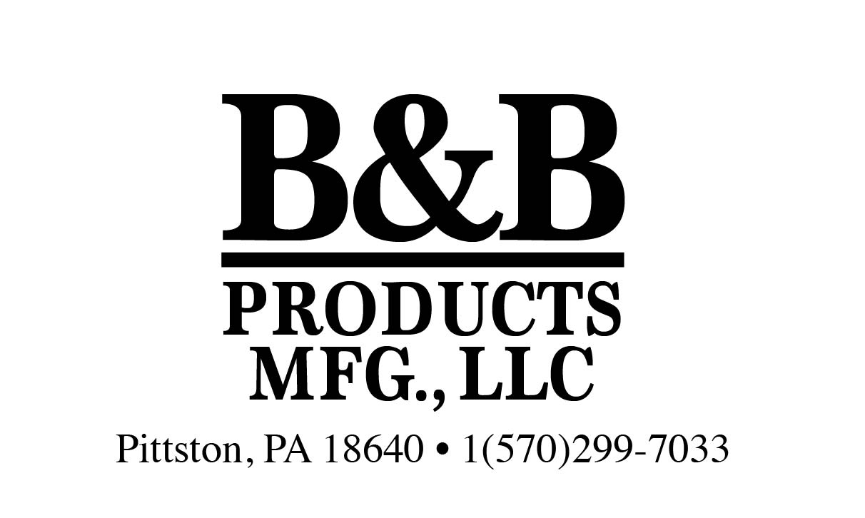

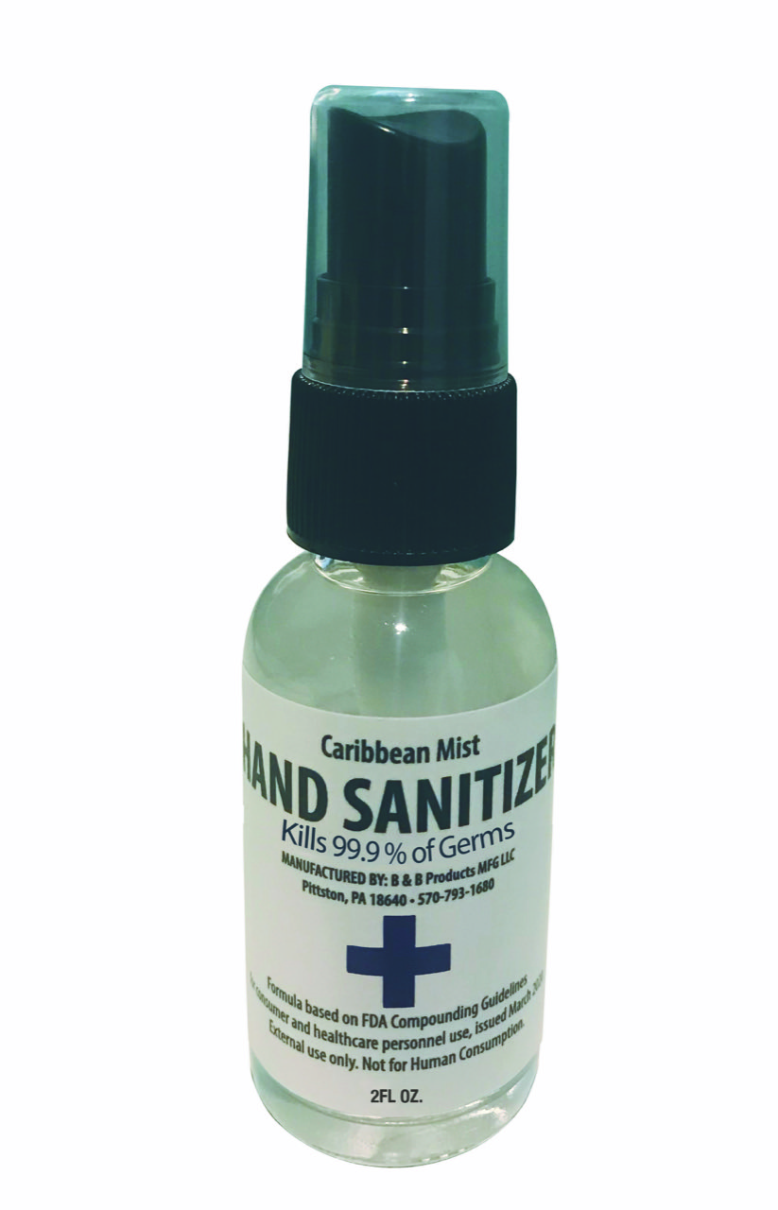

PPE Hand Sanitizer 2oz Spray Bottle
FDA Approved Formula
Great to keep in your purse or pocket
Or children’s backpack
Made in the USA
75% Alcohol Content
Alcohol is 99.9% Pure
FDA Approved Formula
Cost: $1.50 Spray Bottle
Case Pack: 24 Units
Case Dimension: 5” x 6” x 9”
Case Weight: 5.5 lbs
UPC: 8-38337-00015-4
FOB: King of Prussia, PA
Production Capability: 200,000 units per week

